Fibonacci Sequence

Assignment 2

By:

Alexander Rivera

Submitted to:

Prof. Ian O’Toole

CEN 4802C – Software Integration, Configuration, and Testing

Department of Engineering, Computer Programming & Technology

Valencia College – West Campus

5/21/2023

**Introduction**

In this assignment, students will implement the Fibonacci sequence along with implementing Git into their workflow. Students will document their workflow using screenshots in a separate document.

**Requirements**

* A functioning computer
* A working Integrated Development Environment
* Word processing software
* GitHub account
* Internet connection

**Discussion**

In this assignment, the student implemented two methods within one class. The first method called “main” simply prompts the user to enter a number used to calculate the corresponding value in the Fibonacci sequence. The second method, called “sequence”, is used to calculate the Fibonacci values based on the input received from the main method. Throughout development, the student documented finding via ten screenshots and used version control through GitHub. The main branch of this Fibonacci project can be found using the link below.

Link: <https://github.com/arivera247/CEN4802/tree/main/Fibonacci>

**Validation of Data**

Figure - Screenshot of successful calculation of the Fibonacci sequence.

Figure - Screenshot showing Main class added to GitHub repo.

Figure - Newly created issue logged in GitHub.

Figure - Screenshot showing new branch created to address missing documentation issue.

Figure - Screenshot showing Main.java class updated in the MissingDocs branch. Note the status message above stating the branch is 2 commits ahead of the main branch.

Figure - Screenshot demonstrating a newly created pull request for the MissingDocs branch merge into the main branch.

Figure - Screenshot containing side by side comparison of main and MissingDocs branches. Newly added code is highlighed in green within the IDE. For emphasis, newly added code in screenshot was boxed in red using a markup tool.

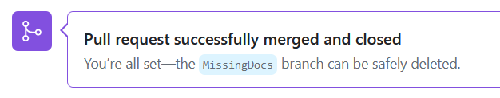

Figure - Screenshot showing both main and MissingDocs branches were merged successfully.

Figure - Screenshot showing remaining branches. The MissingDocs branch is missing since it was deleted after successfully merging the branch to main.

**Conclusion**

Enter your answer here. Use 2-4 sentences.